SWC MemMap shall only be adapted in the user blocks and user blocks are part of the comment blocks marked by "Start of..." and "End of..." for e.g. you can only adapt following lines :

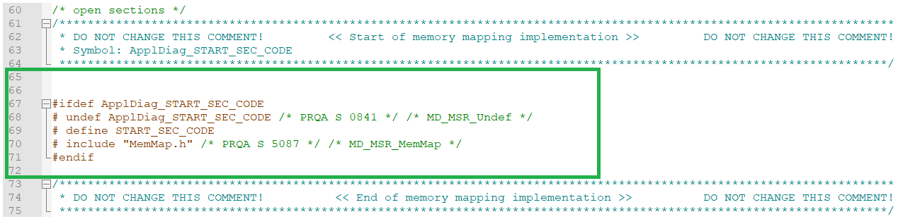

If you write outside of these user blocks then that will get overwritten with next generation. Usually there is no need to add new Start or Stop Memory allocation keywords as the generated keywords are sufficient.

But if you still want to do it, then you can try do so in empty user blocks towards the end. If this doesn't work, then you would need to create your new header files that contains such allocation keywords.

As MEMORY-SECTIONS defined by AUTOSAR cannot be used for this use case, you may need to create additional memory sections. Chapter "5.2.3 Additional Memory Sections" in TechnicalReference_MemMap.pdf defines how to do this. But please note that you would need to access the fitment of this solution for your usecase.

With this approach it is possible to generate additional memory sections for e.g. into Rte_MemMap.h from configuration, which will then get included in SWC source file.  An example configuration with prescribed steps may look something like this :

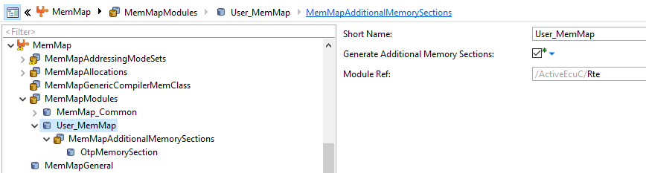

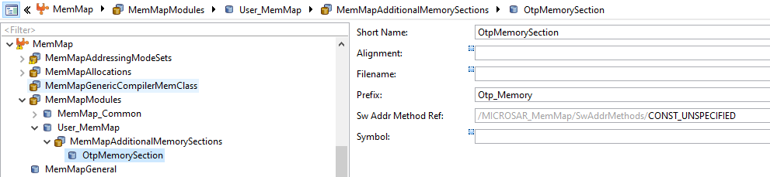

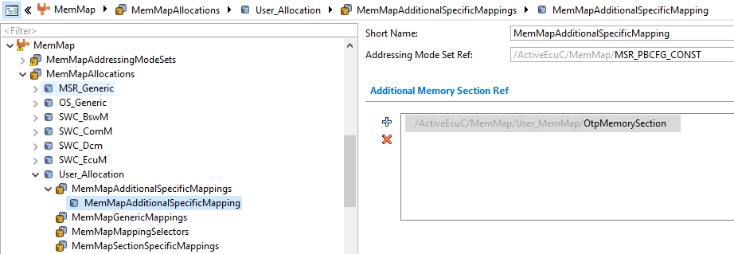

Please note referenced Sw Addr Method and Addressing Mode Set are set just to show you an example. You would need to decide based on your project needs what should be the values there.

With above example configuration, following gets generated into Rte_MemMap.h

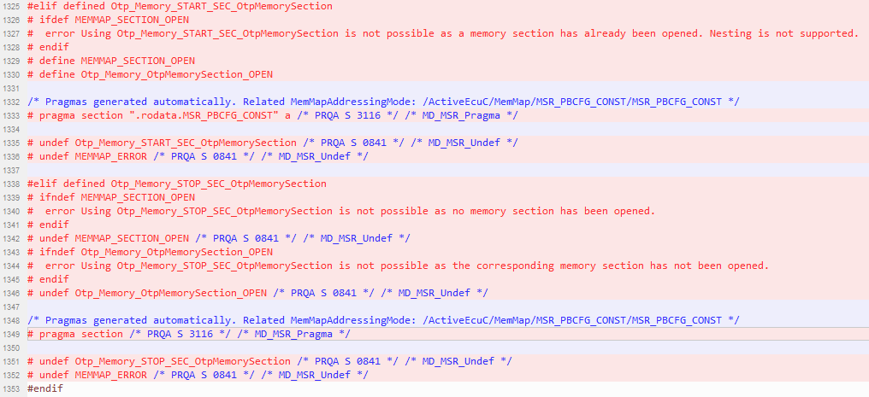

Further, for example you can define the variable like this in your SWC :

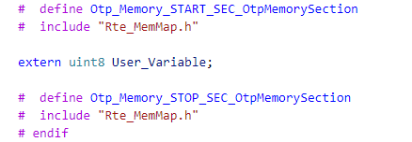

This seems to be the only possibility that fits with your usecase. Otherwise, you can perform the required mapping directly in linker files or in the user defined header files.